Experiment-2
Aim
To read an image using Python and OpenCV and apply Gaussian Blur to reduce noise and smooth the image.
Procedure
- Import the OpenCV library.
- Read the input image using cv2.imread().
- Apply Gaussian Blur using cv2.GaussianBlur().
- Display the original and blurred images.
- Save the blurred image if required.
Code
import cv2

# Read the image
img = cv2.imread("sample image.jpeg")

# Apply Gaussian Blur
blur = cv2.GaussianBlur(img, (5, 5), 0)

# Display images
cv2.imshow("Original Image", img)
cv2.imshow("Gaussian Blurred Image", blur)

cv2.waitKey(0)
cv2.destroyAllWindows()
Sample Input
Input: sample image.jpeg — a color image.
Sample Output
- Original image
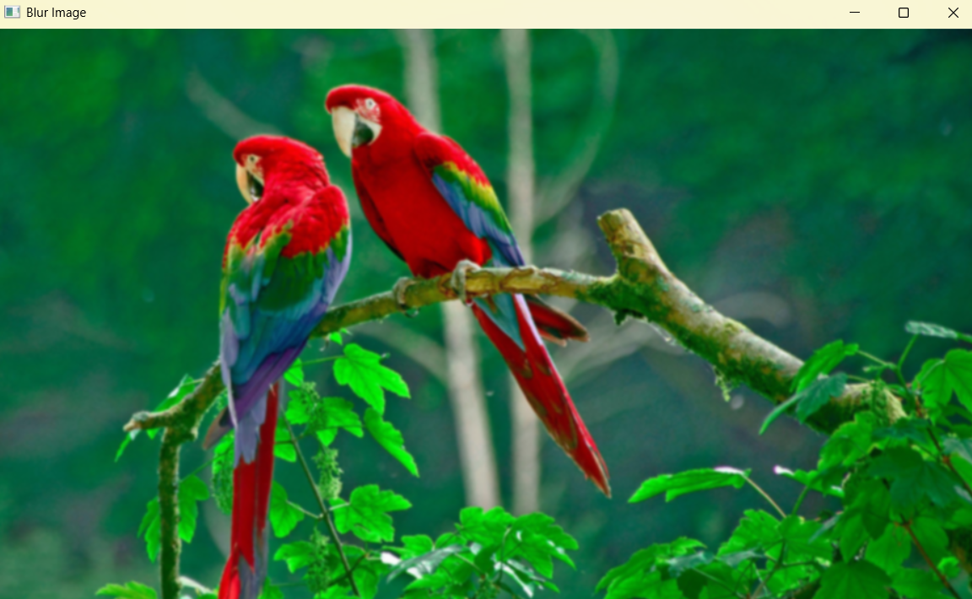
- Gaussian blurred image with a smooth appearance
- 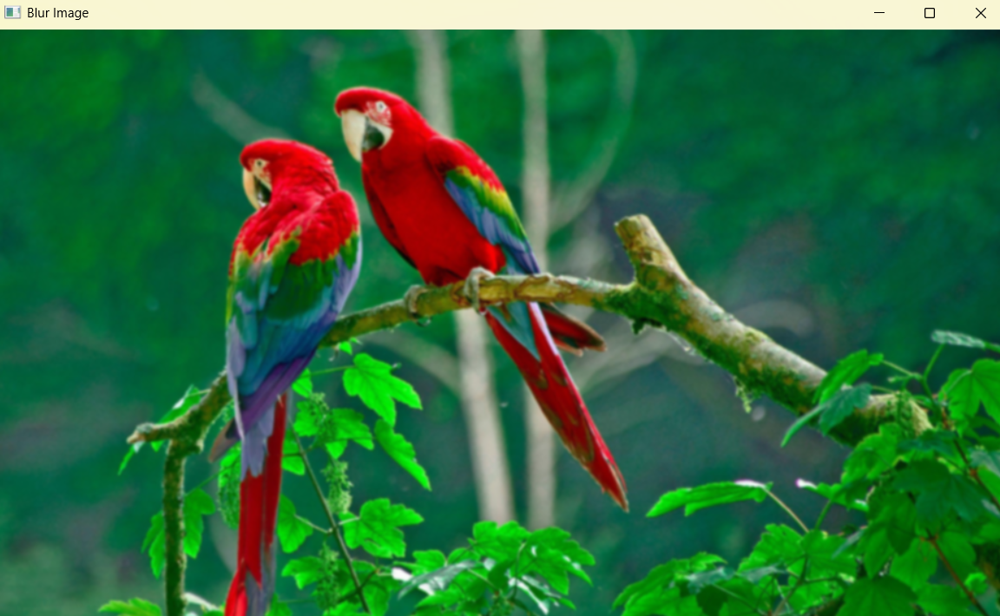
Result
Thus, the given image was successfully blurred using the Gaussian Blur function in OpenCV.

